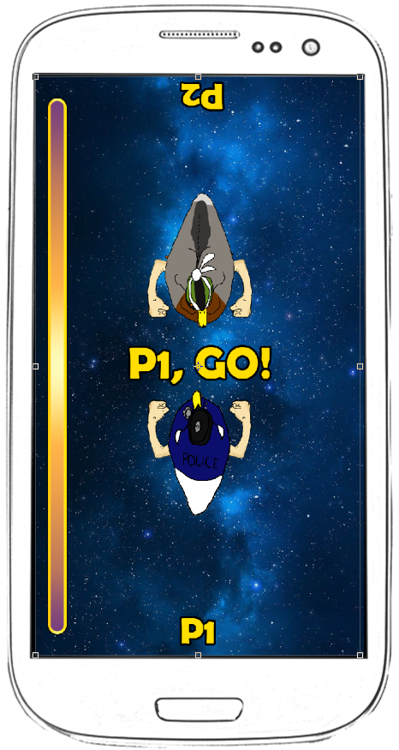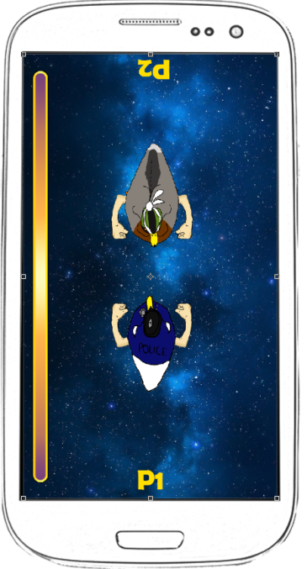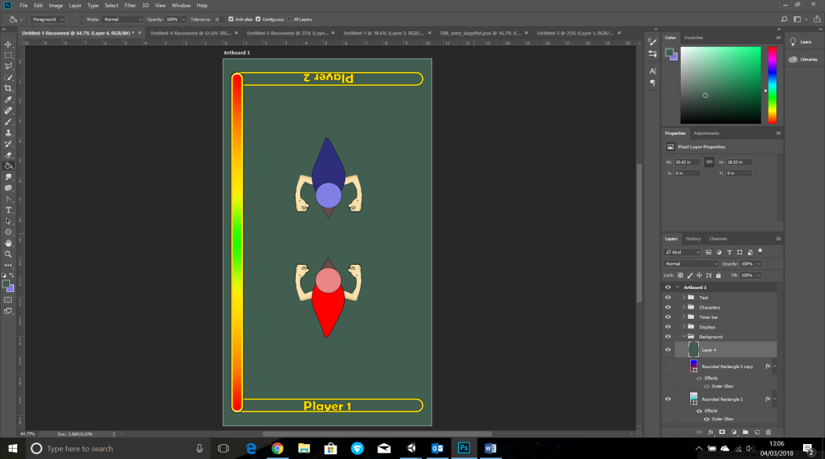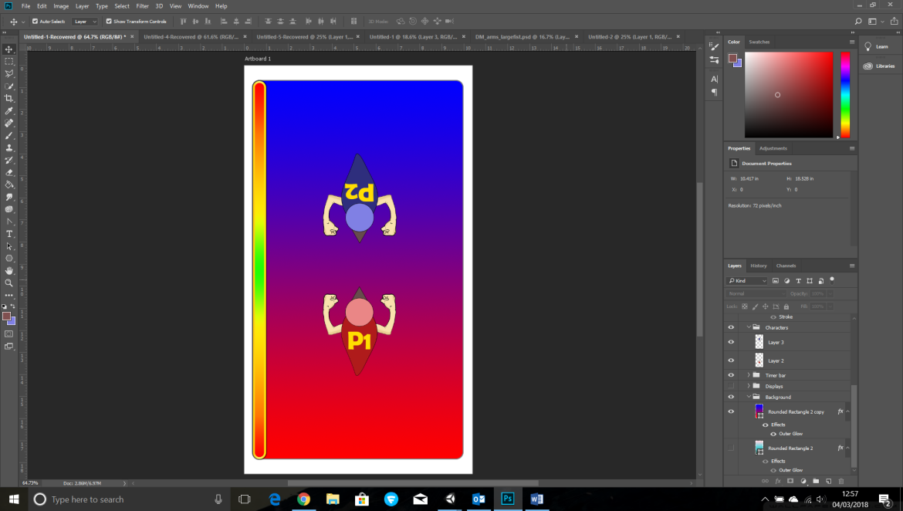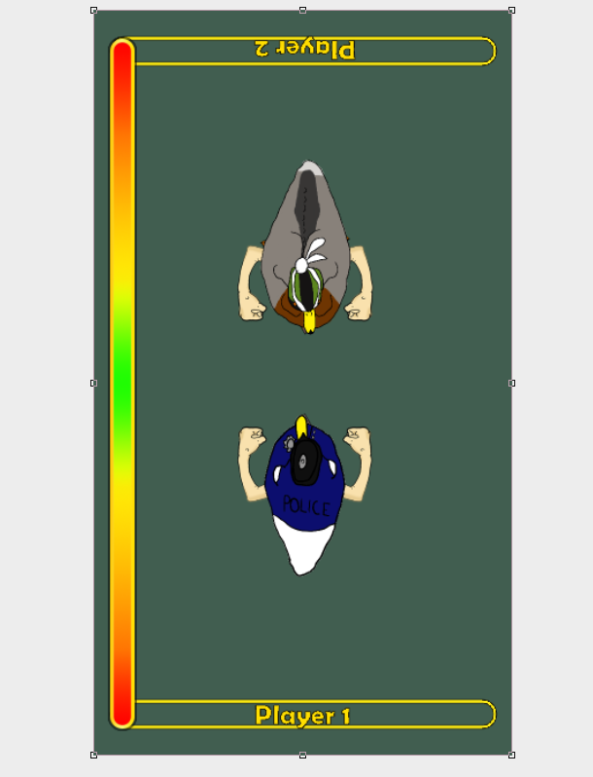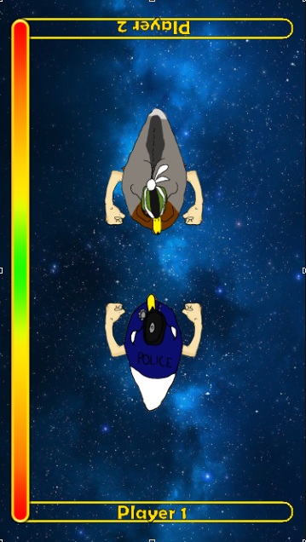



Colour scheme: The player characters will be the most noticeable in terms of colour and detail so that each player will easily identify their player avatar.

The timing bar will also be vibrant in colour so that it is clearly indicated what is a ‘good’ area and a ‘bad’ area of the bar. The colours should be completely seperate from the overall colour scheme so that they are easily seen and so they do not blend in with any other colours like in the background or player characters.

UX: Deciding how much information to show the player will be refined through play testing and player feedback but the examples above show different ways how players can identify which character is theirs and which turn it is.

The positioning of each asset is very important to how we want to present knowledge to the player. Using bold, bright contrasting colours for the text clearly indicates information so that the player does not miss any information.

Focus point: The player characters will be the first thing that the player sees when they first start playing the game.

The next thing that will draw the players attention is the timing bar on the side of the game scene followed by the ‘Player’ name.

The background will be the last thing the players pay attention too.

